AI Project Report – Sidrit Rrustemi & Viola Zeneli

Topic: Intelligent Employee Attrition Prediction Agent


- Project Overview
This project builds an intelligent learning agent that predicts employee attrition - whether an employee is likely to leave (Yes) or stay (No) - based on HR-related information such as job role, satisfaction level, income, and work experience. The study is based on the “Employee Attrition & Retention Analytics Dataset”, obtained from Kaggle, which contains real-world employee records commonly used for attrition analysis.
The main goal of the project is to develop a model that is useful under realistic conditions. In real HR data, far more employees stay than leave, which makes the dataset highly imbalanced. As a result, a model can appear accurate by predicting “stay” for most employees, while still failing to correctly identify those who actually leave. For this reason, the project emphasizes evaluation metrics that better reflect performance on the attrition class, particularly the F1-score, and applies techniques to reduce the impact of class imbalance.
- Problem Formulation – PEAS Framework
The employee attrition prediction problem is modeled as a task environment for an intelligent agent, where the agent observes employee-related information and produces attrition predictions that support human resource decision-making.
PEAS Component | Description
Performance Measure | The agent is evaluated using Accuracy, Precision, Recall, and F1-score. While accuracy reflects overall correctness, F1-score is prioritized, since failing to identify employees who leave is more costly than incorrectly flagging employees who stay.
Environment | The environment consists of a company’s human resources domain, represented by historical employee records with demographic, job, and satisfaction data.
Actuators | The agent outputs a binary attrition decision (Leave/Stay) and can modify its behavior through different decision thresholds to support various organizational strategies.
Sensors | The agent perceives the environment through employee features obtained from HR records, such as age, department, salary, job satisfaction, working years, and overtime status.
- Agent Design and Task Environment
The implemented system is a learning agent because it learns patterns from historical employee data using machine learning models and improves its predictions through training and evaluation, rather than following fixed rules or predefined actions.
Task environment characteristics:
- Partially observable - The agent only observes recorded employee attributes, while many factors influencing attrition (such as personal intentions or external opportunities) are not available.
- Stochastic (Non-Deterministic) - Employee attrition cannot be predicted with certainty, as similar employees may still make different decisions.
- Static - The environment remains unchanged while the agent makes a prediction for an employee.
- Episodic - Each prediction is made independently for each employee, without dependence on previous predictions.
- Mixed (Discrete and Continuous) - The environment includes both categorical inputs (e.g., department, job role) and numerical inputs (e.g., income, years of experience).
- Known - The agent knows the structure of the task, the input features, and the expected output.
- Single-agent - The agent operates alone and does not interact or compete with other agents.
- Model Selection
This project uses statistical learning models because employee attrition prediction involves complex, non-linear relationships between multiple employee attributes that cannot be captured using simple rules or heuristics. Among many possible models, we selected Random Forest (RF) and XGBoost due to their suitability for structured, imbalanced HR data and their strong empirical performance.
Random Forest (RF) | XGBoost
Random Forest is appropriate for this problem because it combines multiple decision trees to reduce overfitting and improve generalization. It can naturally handle mixed feature types (categorical and numerical) and capture non-linear relationships between employee characteristics and attrition. Compared to a single Decision Tree, Random Forest is more stable and less sensitive to noise. Compared to simpler linear models such as Logistic Regression, it can model complex interactions without requiring strong assumptions about feature relationships. | XGBoost is well-suited for attrition prediction because it uses gradient boosting to iteratively improve model performance by focusing on previously misclassified cases, which is particularly useful in imbalanced datasets. Its regularization mechanisms help control model complexity and prevent overfitting. Compared to Random Forest, XGBoost often achieves higher predictive performance due to its sequential learning process. Compared to traditional boosting or simpler classifiers, it provides better control over model complexity and more efficient learning on large, structured datasets.
- Implementation
The intelligent agent was implemented as a structured machine learning pipeline.
Preprocessing included:

After preprocessing, Random Forest and XGBoost models were trained on the balanced training data. For each model, hyperparameter tuning was performed by evaluating various configurations to balance performance and computational cost. Model evaluation was conducted using accuracy, precision, recall, and F1-score, with emphasis on the attrition class.
The final model also supports adjustable decision thresholds, feature importance analysis.
The intelligent agent was demonstrated through an interactive Streamlit web application, deployed at: https://employeeattritionai.streamlit.app
- Evaluation & Results - Random Forest

Hyperparameter Tuning
Many different hyperparameter configurations were tested at first, but only ten were chosen for evaluation, since trying all possible combinations would take too much time. Because the dataset is imbalanced, the final model was selected mainly based on the F1-score rather than accuracy.
Among all tested configurations, Case 5 achieved the highest F1-score while maintaining strong recall, indicating a balanced ability to detect employees who leave while limiting unnecessary false positives. This configuration was therefore selected as the best Random Forest model and is used as the representative Random Forest baseline in later comparisons with other learning techniques.
Case | n_  estimators | max_depth | min_samples_split | min_samples_leaf | max_features | Best Threshold | Accuracy | F1 Score | Precision | Recall
1 | 500 | 10 | 5 | 2 | sqrt | 0.34 | 0.8129 | 0.5455 | 0.4459 | 0.7021
2 | 1000 | 10 | 10 | 4 | sqrt | 0.34 | 0.8061 | 0.5440 | 0.4359 | 0.7234
3 | 1500 | 15 | 10 | 5 | log2 | 0.32 | 0.7857 | 0.5333 | 0.4091 | 0.7660
4 | 800 | 20 | 8 | 3 | sqrt | 0.32 | 0.7959 | 0.5313 | 0.4198 | 0.7234
5 | 1200 | None | 15 | 6 | sqrt | 0.35 | 0.8061 | 0.5512 | 0.4375 | 0.7447
6 | 400 | 25 | 12 | 4 | log2 | 0.32 | 0.7755 | 0.5286 | 0.3978 | 0.7872
7 | 1000 | 30 | 5 | 2 | sqrt | 0.30 | 0.8027 | 0.5469 | 0.4321 | 0.7447
8 | 1500 | 20 | 10 | 4 | sqrt | 0.33 | 0.8061 | 0.5512 | 0.4375 | 0.7447
9 | 700 | 15 | 20 | 8 | log2 | 0.37 | 0.7993 | 0.5426 | 0.4268 | 0.7447
10 | 1000 | None | 10 | 10 | sqrt | 0.37 | 0.8027 | 0.5469 | 0.4321 | 0.7447

Confusion Matrix
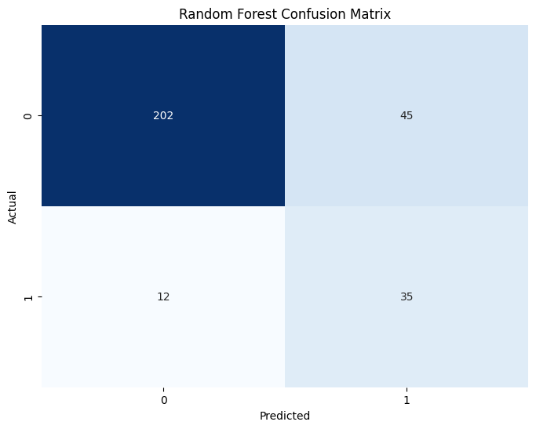

Best Performance Metrics
Using the best configuration (Case 5) and the optimal threshold of 0.35, the model was evaluated on the test set.
Metric | Value
Accuracy | 0.8061
Precision (Attrition = 1) | 0.4375
Recall (Attrition = 1) | 0.7447
F1-Score (Attrition = 1) | 0.5512

Classification Report Analysis
The class-wise performance of the Random Forest model is shown below.
Class | Precision | Recall | F1-Score
Stay (0) | 0.9439 | 0.8178 | 0.8764
Leave (1) | 0.4375 | 0.7447 | 0.5512

Performance Interpretation and Analysis

From the evaluation metrics shown in Table “Best Performance Metrics”, the model achieves a recall of 0.7447 for the attrition class. This means that approximately 74 out of 100 employees who actually leave are correctly identified by the model. In the context of employee attrition, this is important because missing at-risk employees can lead to higher organizational costs. The precision value of 0.4375 indicates that some employees predicted to leave actually stay. This behavior is expected in imbalanced datasets and reflects a deliberate trade-off: the model prioritizes detecting employees who leave, even if this results in additional false positives.
The class-wise results shown in Table “Classification Report Analysis” further support this interpretation. The model performs very strongly on the majority class (employees who stay), with high precision and recall, while still maintaining strong recall for the minority class. This confirms that the model is not biased toward always predicting the majority class, which would otherwise inflate accuracy without providing useful attrition predictions.
Finally, as summarized in Table “Hyperparameter Tuning”, the selected configuration achieves the highest F1-score, which combines precision and recall into a single metric. This indicates that the chosen Random Forest model provides a balanced and reliable performance under class imbalance. Overall, these results show that Random Forest serves as a strong baseline model, suitable for comparison with more advanced techniques in later analysis.

- Evaluation & Results - XGBoost

Hyperparameter Tuning
Many different hyperparameter configurations were tested at first, but only ten were chosen for evaluation, since trying all possible combinations would take too much time. Because the dataset is imbalanced, the final model was selected mainly based on the F1-score rather than accuracy.
Among all tested configurations, Case 4 achieved the highest F1-score while maintaining a good balance between precision and recall. This configuration was therefore selected as the best XGBoost model and is used as the representative XGBoost model in later comparisons.
Case | n_  estimators | max_depth | learning_rate | min_child_weight | gamma | subsample | colsample_bytree | reg_alpha | reg_lambda | Best Threshold | Accuracy | F1 Score
1 | 500 | 4 | 0.050 | 2 | 0.00 | 0.80 | 0.80 | 0.00 | 1.0 | 0.20 | 0.8095 | 0.4909
2 | 1000 | 6 | 0.030 | 3 | 0.10 | 0.80 | 0.80 | 0.10 | 1.0 | 0.28 | 0.8639 | 0.5556
3 | 800 | 5 | 0.040 | 1 | 0.20 | 0.70 | 0.70 | 0.20 | 1.5 | 0.23 | 0.8265 | 0.5143
4 | 1200 | 7 | 0.020 | 4 | 0.15 | 0.85 | 0.85 | 0.15 | 1.2 | 0.33 | 0.8673 | 0.5618
5 | 600 | 8 | 0.060 | 2 | 0.05 | 0.90 | 0.90 | 0.05 | 0.8 | 0.46 | 0.8844 | 0.5526
6 | 800 | 5 | 0.010 | 5 | 0.30 | 0.75 | 0.75 | 0.30 | 2.0 | 0.29 | 0.8265 | 0.5405
7 | 900 | 6 | 0.035 | 3 | 0.10 | 0.80 | 0.80 | 0.10 | 1.0 | 0.20 | 0.8367 | 0.5472
8 | 700 | 4 | 0.070 | 1 | 0.00 | 0.85 | 0.85 | 0.00 | 1.5 | 0.24 | 0.8469 | 0.5361
9 | 900 | 5 | 0.020 | 4 | 0.20 | 0.80 | 0.80 | 0.20 | 1.3 | 0.25 | 0.8265 | 0.5405
10 | 1100 | 6 | 0.030 | 2 | 0.15 | 0.90 | 0.90 | 0.15 | 1.1 | 0.36 | 0.8639 | 0.5238

Confusion Matrix
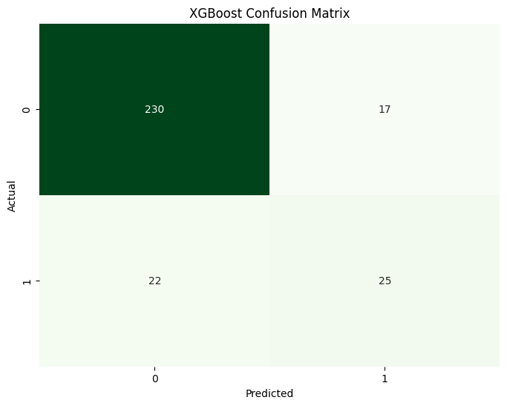
Best Performance Metrics
Using the best configuration (Case 4) and the optimal threshold of 0.33, the model was evaluated on the test set.
Metric | Value
Accuracy | 0.8673
Precision (Attrition = 1) | 0.5952
Recall (Attrition = 1) | 0.5319
F1-Score (Attrition = 1) | 0.5618

Classification Report Analysis
The class-wise performance of the XGBoost model is shown below.
Class | Precision | Recall | F1-Score
Stay (0) | 0.9127 | 0.9312 | 0.9218
Leave (1) | 0.5952 | 0.5319 | 0.5618

Performance Interpretation and Analysis
From the evaluation metrics shown in Table “Best Performance Metrics”, the XGBoost model achieves a recall of 0.5319 for the attrition class. This means that approximately 53 out of 100 employees who actually leave are correctly identified by the model. While this recall is lower than that of Random Forest, it is accompanied by a higher precision.
The precision value of 0.5952 indicates that a larger proportion of employees predicted to leave actually do leave, reducing false positives. This makes XGBoost more conservative in its predictions compared to Random Forest.
The class-wise results shown in Table “Classification Report Analysis” confirm that XGBoost performs very strongly on the majority class, while maintaining balanced performance on the minority class. The resulting F1-score of 0.5618, which is higher than that of Random Forest, shows that XGBoost provides a better overall balance between precision and recall under class imbalance.
Overall, these results demonstrate that XGBoost offers improved accuracy and F1-score compared to Random Forest, making it a strong candidate for the final intelligent agent.
- Final Model Comparison and Selection

After evaluating both Random Forest and XGBoost using the same dataset and evaluation process, a final comparison was made to decide which model is more suitable for the intelligent agent.

Since employee attrition data is highly imbalanced, accuracy alone is not enough to judge performance. For this reason, more importance was given to the F1-score and to how well each model balances precision and recall, as these metrics better reflect the model’s ability to correctly identify employees who are likely to leave.

Model Performance Comparison
Model | Accuracy | Precision  (Attrition = 1) | Recall  (Attrition = 1) | F1-Score  (Attrition = 1)
Random Forest | 0.8061 | 0.4375 | 0.7447 | 0.5512
XGBoost | 0.8673 | 0.5952 | 0.5319 | 0.5618

Final Model Selection

Although the Random Forest model identifies more employees who leave (higher recall), it also produces more false positive predictions. In contrast, XGBoost achieves a better balance between precision and recall, meaning it identifies employees who are likely to leave while reducing incorrect alerts. This balance results in the highest F1-score and higher overall accuracy. Because this behavior is more reliable when companies have limited resources to take follow-up actions, XGBoost was selected as the final model and is used as the intelligent agent in this project.
- Comparison with Existing Research
Several studies have addressed the problem of employee attrition prediction using machine learning techniques. A relevant study is “Employee Attrition Prediction Using Machine Learning Algorithms”, which evaluates multiple classification models under both imbalanced and balanced dataset settings.
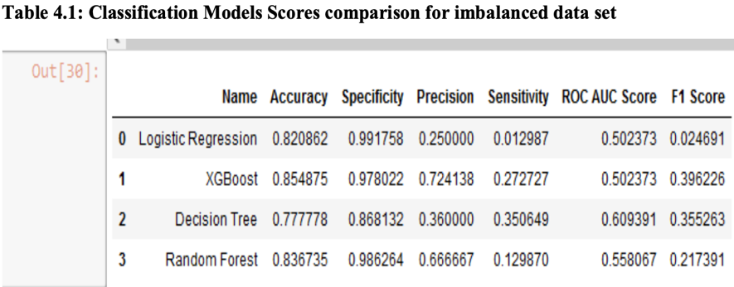
In Experiment 1 of the referenced study, the original imbalanced dataset was used. Due to the strong class imbalance, most models struggled to correctly identify employees who leave. As reported in Table 4.1 of that study, the XGBoost model achieved the best performance among the tested methods, with an F1-score of 0.396, outperforming Logistic Regression, Decision Tree, and Random Forest. While this result highlights the effectiveness of XGBoost, the reported F1-score remains relatively low, indicating difficulty in handling the minority class.
In comparison, our approach achieves a substantially higher F1-score (0.5618) for the attrition class, even under imbalanced conditions. This improvement can be attributed to more careful preprocessing, advanced resampling using SMOTE–Tomek, and threshold optimization, which were not emphasized in the referenced study. As a result, our model is better at balancing precision and recall when identifying employees who leave.
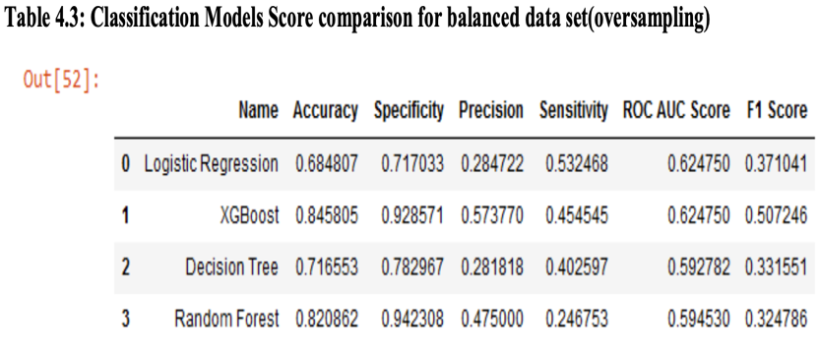
In Experiment 2 of the referenced study, the dataset was balanced using the SMOTE technique. As shown in Table 4.3 of that work, the XGBoost model again achieved the highest performance, with an F1-score of 0.507. Although balancing improved results compared to the imbalanced case, the overall performance remained limited.
By contrast, even after applying SMOTE–Tomek, our XGBoost model achieves a higher F1-score of 0.5618, demonstrating stronger and more stable performance on the balanced dataset. This indicates that the proposed approach not only benefits from data balancing, but also from improved model tuning and evaluation strategy.

Overall, when compared to existing research, the results of this project show consistent improvements in F1-score and a more stable balance between precision and recall, both before and after resampling, indicating effective performance on this dataset.
- Ethical Considerations and Future Improvements

Ethical Considerations
The topic of employee attrition prediction was chosen because it addresses a practical and ethical challenge faced by organizations: understanding why employees leave and how this information can be used to improve retention in a fair and responsible way. The intention of this project is to support early awareness and positive action, such as improving working conditions or employee satisfaction, rather than monitoring or penalizing individuals.
The proposed intelligent agent is designed as a decision-support tool, not as an automated decision-maker. Predictions are meant to assist HR professionals in identifying potential risk patterns, while final decisions remain under human control to avoid unfair treatment.
To support ethical use, the system emphasizes transparency and responsible interpretation of results. Outputs such as feature importance help explain model behavior, and the approach assumes secure handling of employee data. Overall, the topic was chosen to apply artificial intelligence in a useful, responsible, and human-centered manner.

Future Improvements
The current intelligent agent performs well, but its performance can be further improved to better handle real-world employee attrition scenarios. These improvements focus on reducing critical prediction errors, capturing more informative patterns, and improving practical deployment.
- Cost-sensitive learning - Assigning higher penalties to misclassifying employees who leave would help the model focus on the most important errors caused by class imbalance.
- Richer and larger datasets - Using more data samples and additional employee-related features would improve model generalization and help better capture the complexity of human behaviour involved in attrition decisions.
- Further model tuning - Testing additional hyperparameter configurations or combining multiple models could lead to small performance improvements.
- System integration - Integrating the agent into real HR systems would allow continuous updates and practical usage.
- Conclusion

In this project, an intelligent learning agent for employee attrition prediction was designed, implemented, and evaluated under realistic conditions. By addressing class imbalance and using appropriate evaluation metrics, the system achieves strong and consistent results on this dataset, especially when compared to existing research. Among the evaluated models, XGBoost was selected as the final agent because it provides a better balance between precision and recall and achieves the highest F1-score. The final system, supported by an interactive deployment, demonstrates how artificial intelligence can be applied in a practical, responsible, and human-centered manner.

Employee Attrition and Retention Analytics Dataset, Kaggle: https://www.kaggle.com/datasets/ajinkyachintawar/employee-attrition-and-retention-analytics-dataset
Employee Attrition Prediction Using Machine Learning Algorithms, ResearchGate, 2022. Available at: https://www.researchgate.net/publication/364322002_EMPLOYEE_ATTRITION_PREDICTION_USING_MACHINE_LEARNING_ALGORITHMS

